**EE6094 CAD for VLSI Design**

**Programming Assignment 4: Routing**

Student ID: 108501023

Student Name: 李品賢

**Compile, Execute and Verification**

1. Pulls the source code, i.e., *108501023_PA4.cpp*, *Makefile*, *case0.txt*, *case7.txt*, *case8.txt* and *checker* into the workstation folder.

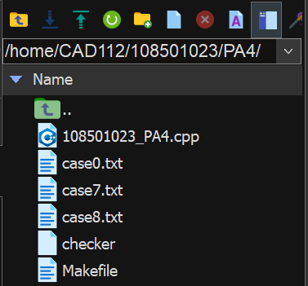

Fig. 1

1. Uses *Makefile* as a trigger point to run the *108501023_PA4.cpp* program, and then output files *out0.txt* / *out7.txt* / *out 8.txt* are generated.

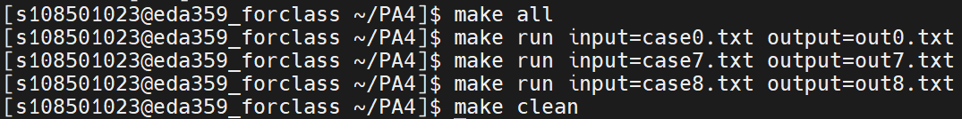

Fig. 2

* + make all
  + make run intput=case0.txt output=out0.txt
  + make run intput=case7.txt output=out7.txt
  + make run intput=case8.txt output=out8.txt
  + make clean

1. Uses checker to check whether output files fits the standard output format.
   * ./checker out0.txt case0.txt
   * ./checker out7.txt case7.txt
   * ./checker out8.txt case8.txt

**Completion**

All three cases are successfully passed the checker. The following three figures (Fig. 3, Fig. 4, Fig. 5) are results.

|  |  |  |  |
| --- | --- | --- | --- |
|  | case0 | case7 | case8 |
| Completion | O | O | O |
| # of track | 3 | 3 | 4 |

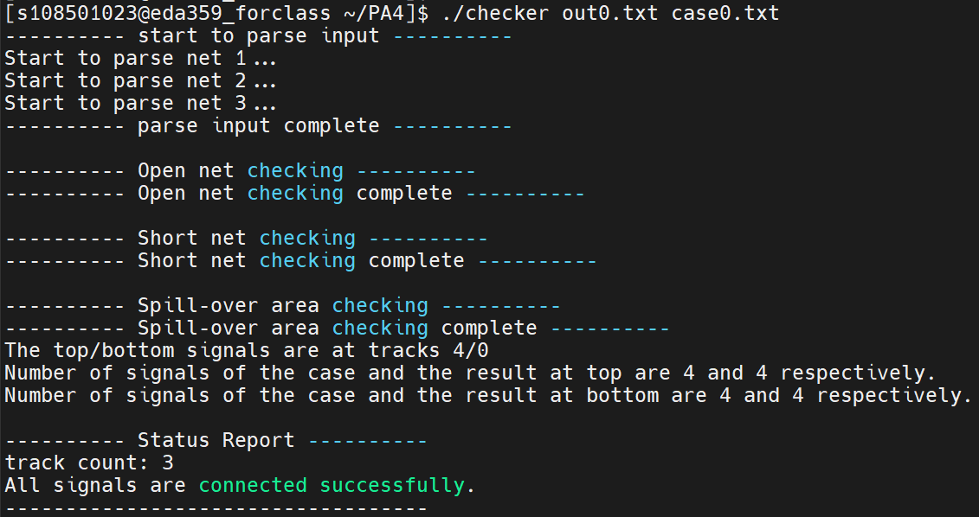

Fig. 3

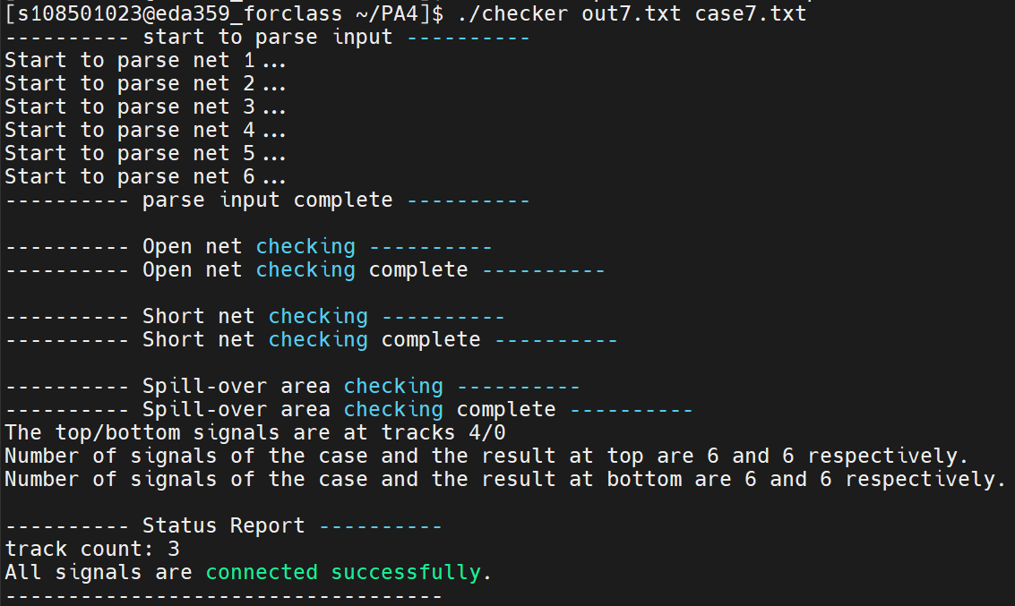

Fig. 4

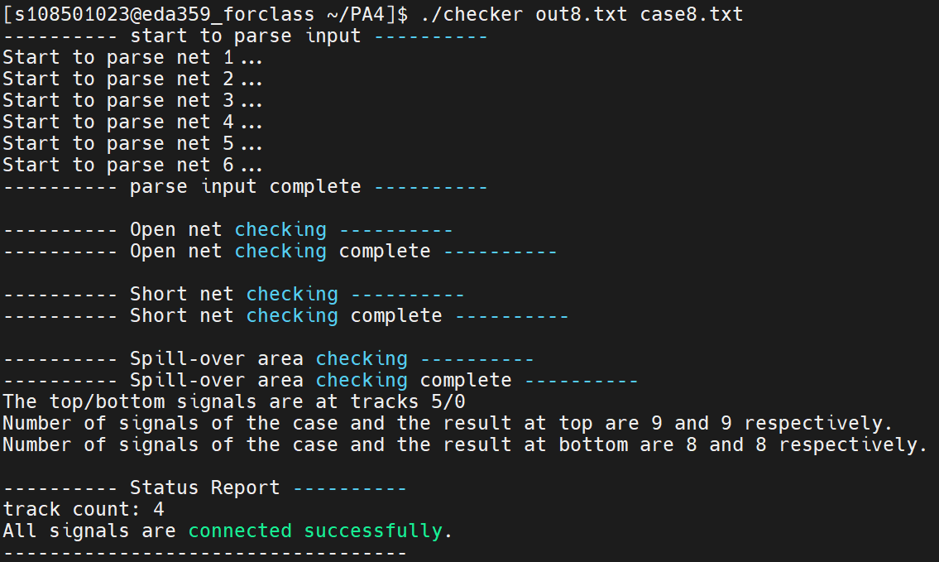

Fig. 5

**Data structure**

Due to the simplicity of basic left edge algorithm, the only slightly complicated data structure is vertical constraint graph (VCG). This graph focuses on the precedence of each node, so I use the simple 1-D adjacent graph data structure to represent VCG.

Fig. 6 shows a channel routing and also the VCG of it. This channel could be represented by adjacent graph in Fig.7. Each head node records the number of its predecessor and then points to its successors.

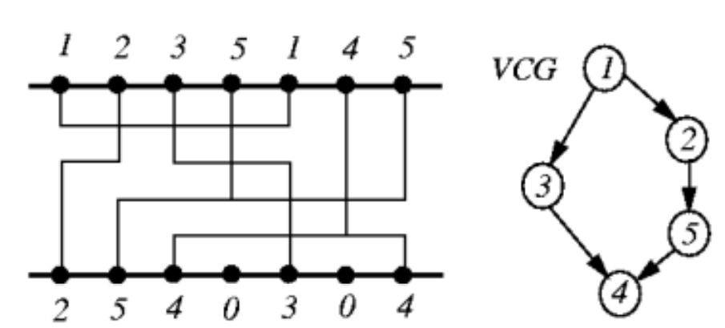

Fig. 6

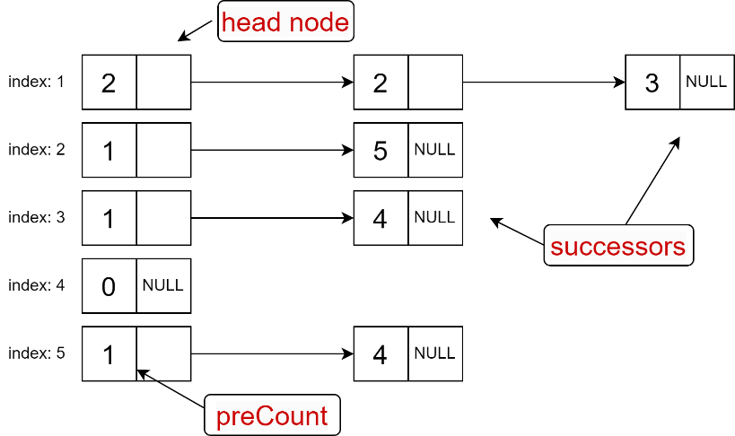

Fig. 7

**Algorithm**

In this program, the main algorithm is basic left edge algorithm (Fig. 8). It’s pretty similar to solving the activity selection problem, and the only difference is that the basic left edge algorithm need to repeat until all horizontal intervals are scheduled.

In one iteration, one track is formed. In a track, horizontal intervals without overlapping could be scheduled on it, and this is achieved by *watermark* variable. Finally, all horizontal intervals are scheduled, and this function terminates. Then, the only thing needed to do is output all tracks in standard format.

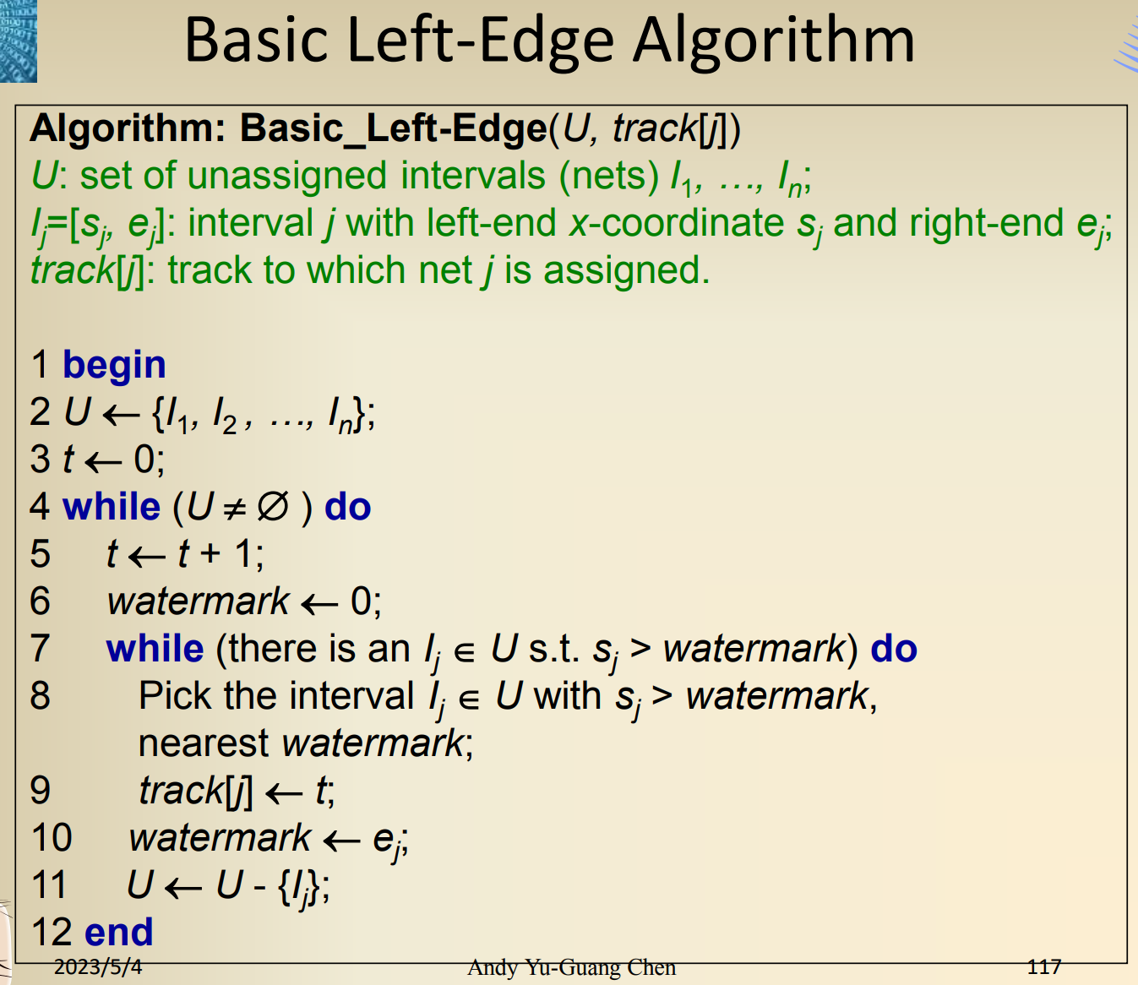

Fig. 8

**Flow Chart**

1. Overall program flow chart



Fig. 9

1. Basic left edge algorithm flow chart

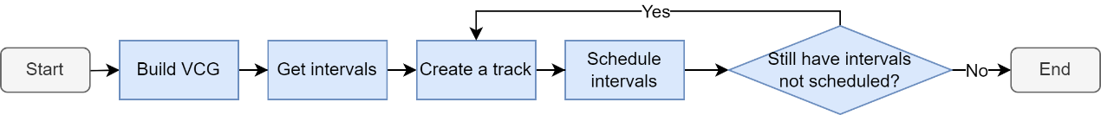

Fig. 10

**Data structure in program**

1. **class Pin** – indicates the information of each pins

|  |  |  |
| --- | --- | --- |
| **Data type** | **Name** | **Purpose** |
| bool | valid | Records if the pin exists in the input file |
| int | preCount | Records the predecessor count of pins |
| int | trackNum | Records the number of tracks of pins |
| Interval | I | Records the horizontal interval of pins |
| vector<int> | TOP_loc | Records the pin location on the top channel |
| vector<int> | BOT_loc | Records the pin location on the bottom channel |
| class Node * | ptr | Points to its successor |

1. **class Node** – indicates the precedence of each pins

|  |  |  |
| --- | --- | --- |
| **Data type** | **Name** | **Purpose** |
| int | pinNun | Records the pin number of the successor |
| class Node * | ptr | Points to another successor of pins |

1. **class Interval** – indicates the horizontal interval of each pin

|  |  |  |
| --- | --- | --- |
| **Data type** | **Name** | **Purpose** |
| int | pinNun | Records which pin number the horizontal interval belongs to |
| int | left | Records the starting location of the horizontal interval |
| int | right | Records the end location of the horizontal interval |
| bool | update | Records if the interval is scheduled |

**Important variables**

|  |  |  |
| --- | --- | --- |
| **Data type** | **Name** | **Purpose** |
| vector<int> | TOP | Stores pins in the top channel |
| vector<int> | BOT | Stores pins in the bottom channel |
| vector< vector<Interval>> | track | Stores horizontal intervals in each track |
| vector<Interval> | I | Stores all horizontal intervals of pins |
| vector<Pin> | pin | Stores the information of each pin |
| int | columnCount | Stores the column count of the channel |
| int | ICount | Stores the horizontal interval count of all horizontal intervals |

**Important functions**

(The list ignores the “Routung::” mark and arguments of functions)

|  |  |
| --- | --- |
| 1. | void build_graph() |
|  | Uses this function to build the vertical constraint graph. |
| 2. | void get_interval() |
|  | Uses this function to collect each horizontal interval from the information of pins in top/bottom channel. |
| 3. | void left_edge() |
|  | Implements the basic left edge algorithm. First calls *build_graph()* function and *get_interval()* function, and then sorts horizontal intervals by its starting location. Afterward, creates a track and schedules the compatible horizontal intervals to it by using *watermark* variable. Repeats again and again until Icount is equal to 0. |

**Makefile**

Because I use single .cpp file in this project, there is only one executable file created, i.e., *108501023_PA4.o*. The following is source code of *Makefile*.

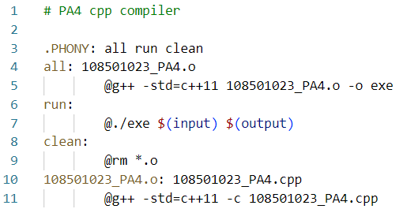

Fig. 11

**Hardness**

The hardest part is to build the vertical constraint graph, but actually it’s not quite difficult. I could imagine that the data structure of VCG would be very complex if I implement the program in dog leg version.

**Suggestion**

I am grateful for having this project, it helps me integrating data structure background into this project.

**Reference**

1. 2023Spring_EE6094_CAD_Chapter11_Routing_20230504_0210
2. https://www.youtube.com/watch?v=DRvNcOQbYV8&ab_channel=JohnReuben